Use case summary

|  |  |
| --- | --- |
| **Use Case Number** | **Use Case Name** |
| 01 | Member Register |
| 02 | Administrator Register |
| 03 | User Login |
| 04 | Search/View Member Information |
| 05 | Edit Member Information |
| 06 | Delete Member |
| 07 | View User Information |
| 08 | Edit User Information |
| 09 | View Friend List |
| 10 | Delete Friend |
| 11 | Find Friend |
| 12 | Send Friend Request |
| 13 | Accept Friend Request |
| 14 | Delete Friend Request |
| 15 | Send Personal Message |
| 16 | View Personal Message |
| 17 | Delete Personal Message |
| 18 | Search/View Dining Event Information |
| 19 | Delete Dining Event |
| 20 | Create Dining Event |
| 21 | Join Dining Event |
| 22 | Give Dining Event Comment |
| 23 | Dining Event Alert |
| 24 | Search/View Restaurant Information |
| 25 | Create Restaurant Record |
| 26 | Edit Restaurant Record |
| 27 | Delete Restaurant Record |
| 28 | Give Restaurant Comment |
| 29 | Delete Restaurant Comment |
| 30 | Create Discount Coupon |
| 31 | Edit Discount Coupon |
| 32 | Delete Discount Coupon |
| 33 | Get Discount Coupon |
| 34 | View Owned Discount Coupon |
| 35 | Contact Us |

Class Diagram

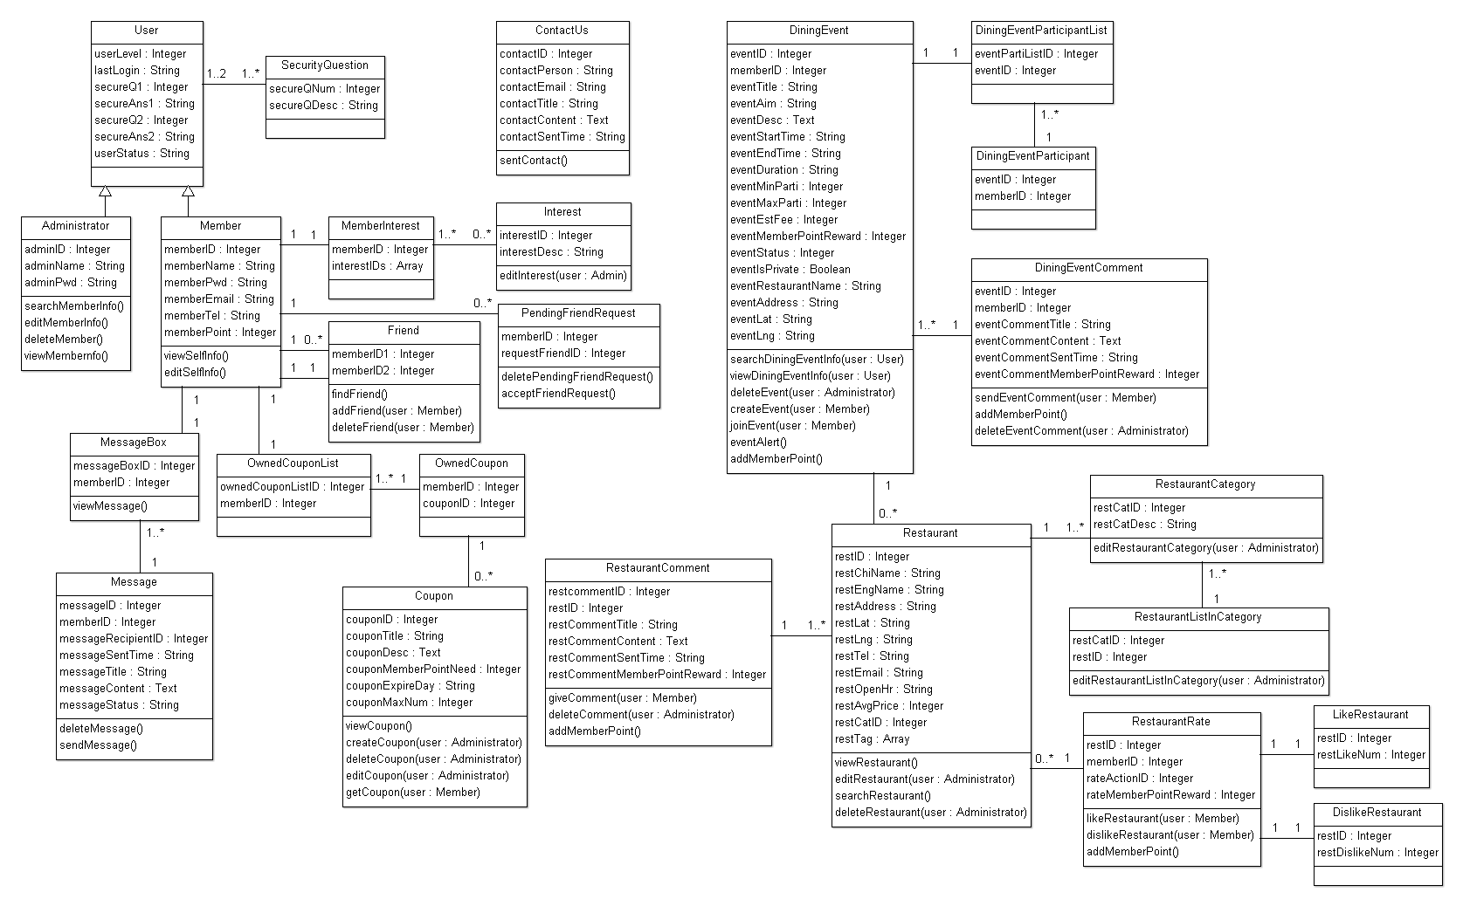

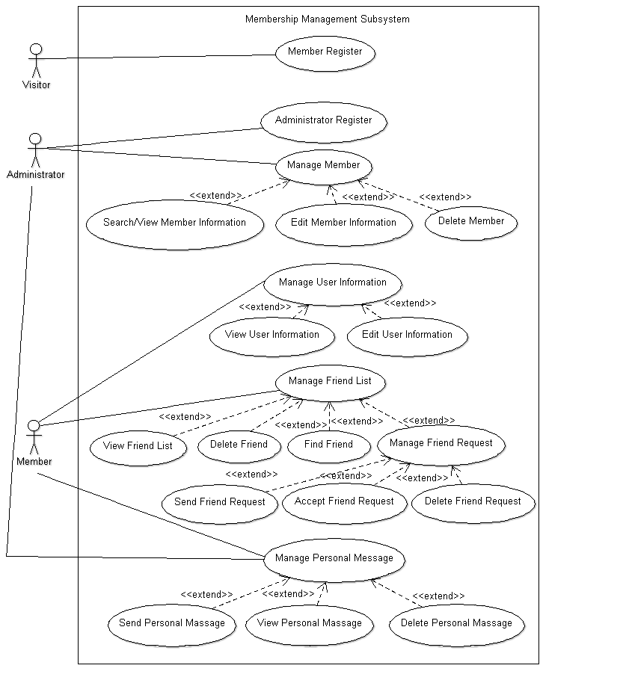

|  |  |  |
| --- | --- | --- |
| Use Case [number 01] | Member Register. | |
| Goal in Context | Register as member | |
| Preconditions | Visitor has not login | |
| Success End Condition | Become a member | |
| Failed End Condition | Cannot become a member | |
| Primary Actor | Visitor | |
| Secondary Actor |  | |
| Trigger | Select member register | |
| Description | Step | Action |
|  | 1 | Input user name, password, email, phone number, interest, and 2 security question with answer |
| Extensions or Variations | Step |  |
| Required Data | memberName, memberPwd, memberEmail, memberTel, memberPoint, secureQ1, secureAns1, secureQ2, secureAns2 | |
| Updated Data | memberID, memberName, memberPwd, memberEmail, memberTel, memberPoint, secureQ1, secureAns1, secureQ2, secureAns2 | |

|  |  |  |
| --- | --- | --- |
| Use Case [number 02] | Administrator Register. | |
| Goal in Context | Create another administrator | |
| Preconditions | Login as administrator | |
| Success End Condition | Another administrator is created | |
| Failed End Condition | Cannot become a member | |
| Primary Actor | Administrator | |
| Secondary Actor |  | |
| Trigger | Select administrator register | |
| Description | Step | Action |
|  | 1 | Input user name, password, email, phone number, interest, and 2 security question with answer |
| Extensions or Variations | Step |  |
| Required Data | adminName, adminPwd, secureQ1, secureAns1, secureQ2, secureAns2 | |
| Updated Data | adminID, adminName, adminPwd, secureQ1, secureAns1, secureQ2, secureAns2 | |

|  |  |  |
| --- | --- | --- |
| Use Case [number 03] | User Login. | |
| Goal in Context | Login to the system | |
| Preconditions | Login as administrator | |
| Success End Condition | Login to the system as member or administrator | |
| Failed End Condition | Fail to login, account lock | |
| Primary Actor | Visitor | |
| Secondary Actor |  | |
| Trigger | Select user login | |
| Description | Step | Action |
|  | 1 | Input user name, password, and select member/administrator |
| Extensions or Variations | Step | Input wrong either user name or password |
|  | 1 | Output error message, request input again |
|  | Step | Wrongly input at the 5th time |
|  | 1 | Output error message, request input security question |
|  | Step | Failed to answer the security question |
|  | 1 | Lock the account for 30 minutes |
|  | Step | Forget password |
|  | 1 | Request input security question |
| Required Data | userLevel, adminName/memberName, adminPwd/memberPwd, secureQ1, secureAns1, secureQ2, secureAns2 | |
| Updated Data | userStaus, lastLogin | |

|  |  |  |
| --- | --- | --- |
| Use Case [number 04] | Search/View Member Information | |
| Goal in Context | Search for member information | |
| Preconditions | Login as administrator | |
| Success End Condition | View member information | |
| Failed End Condition | Output error message | |
| Primary Actor | Administrator | |
| Secondary Actor |  | |
| Trigger | Select manage member from the administrator home page | |
| Description | Step | Action |
|  | 1 | Input member name or ID |
| Extensions or Variations | Step |  |
| Required Data | memberName/memberID | |
| Updated Data |  | |

|  |  |  |
| --- | --- | --- |
| Use Case [number 05] | Edit Member Information | |
| Goal in Context | Change a member’s Information | |
| Preconditions | Login as administrator | |
| Success End Condition | Changed information is saved | |
| Failed End Condition |  | |
| Primary Actor | Administrator | |
| Secondary Actor |  | |
| Trigger | Viewed a member’s information and select edit member information | |
| Description | Step | Action |
|  | 1 | Edit the information |
|  | 2 | Select save |
| Extensions or Variations | Step | Give up to change the information |
|  | 1 | Do not click save and back to administrator home page |
| Required Data | memberID, memberName, memberPwd, memberEmail, memberTel, memberPoint, secureQ1, secureAns1, secureQ2, secureAns2, members | |
| Updated Data | memberName, memberPwd, memberEmail, memberTel, memberPoint, secureQ1, secureAns1, secureQ2, secureAns2 | |

|  |  |  |
| --- | --- | --- |
| Use Case [number 06] | Delete Member | |
| Goal in Context | Delete a member | |
| Preconditions | Login as administrator | |
| Success End Condition | Member is deleted | |
| Failed End Condition |  | |
| Primary Actor | Administrator | |
| Secondary Actor |  | |
| Trigger | Viewed a member’s information and select delete member | |
| Description | Step | Action |
|  | 1 | Select delete user |
|  | 2 | Enter administrator password to confirm delete |
| Extensions or Variations | Step | Give up to delete |
|  | 1 | Do not click the confirm and back to administrator home page |
| Required Data | memberID, memberName, memberPwd, memberEmail, memberTel, memberPoint, secureQ1, secureAns1, secureQ2, secureAns2, adminID, adminName, adminPwd | |
| Updated Data | memberID, memberName, memberPwd, memberEmail, memberTel, memberPoint, secureQ1, secureAns1, secureQ2, secureAns2, MemberInterest, MessageBox, OwnedCouponList, Friend, Pending FriendRequest, OwnedCoupon | |

|  |  |  |
| --- | --- | --- |
| Use Case [number 07] | View User Information | |
| Goal in Context | View user information, interest, and member point of himself/herself. | |
| Preconditions | Login as member | |
| Success End Condition | The member’s information, interest, and member point is output. | |
| Failed End Condition |  | |
| Primary Actor | Member | |
| Secondary Actor |  | |
| Trigger | Select view user information from the member home page | |
| Description | Step | Action |
|  | 1 | Select delete user |
| Extensions or Variations | Step | Give up to delete |
| Required Data | memberID, memberName, memberPwd, memberEmail, memberTel, memberPoint, secureQ1, secureAns1, secureQ2, secureAns2, MemberInterest | |
| Updated Data |  | |

|  |  |  |
| --- | --- | --- |
| Use Case [number 08] | Edit User Information | |
| Goal in Context | Edit user information or interest | |
| Preconditions | Login as member | |
| Success End Condition | The changed user information is saved. | |
| Failed End Condition |  | |
| Primary Actor | Member | |
| Secondary Actor |  | |
| Trigger | Select view user information from the member home page | |
| Description | Step | Action |
|  | 1 | Select edit user |
|  | 2 | Edit information |
|  | 3 | Save |
| Extensions or Variations | Step | Give up editing |
| Required Data | memberID, memberName, memberPwd, memberEmail, memberTel, memberPoint, secureQ1, secureAns1, secureQ2, secureAns2, MemberInterest, Interest | |
| Updated Data | memberID, memberName, memberPwd, memberEmail, memberTel, memberPoint, secureQ1, secureAns1, secureQ2, secureAns2, MemberInterest, Interest | |

|  |  |  |
| --- | --- | --- |
| Use Case [number 09] | View Friend List | |
| Goal in Context | Show all friends | |
| Preconditions | Login as member | |
| Success End Condition | Show friends list | |
| Failed End Condition |  | |
| Primary Actor | Member | |
| Secondary Actor |  | |
| Trigger |  | |
| Description | Step | Action |
|  | 1 | Select friend from the member home page |
| Extensions or Variations | Step |  |
| Required Data | Friend | |
| Updated Data |  | |

|  |  |  |
| --- | --- | --- |
| Use Case [number 10] | Delete Friend | |
| Goal in Context | Delete friend from friend list | |
| Preconditions | Login as member | |
| Success End Condition | Delete a friend from friend list | |
| Failed End Condition |  | |
| Primary Actor | Member | |
| Secondary Actor |  | |
| Trigger | Select friend from the member home page | |
| Description | Step | Action |
|  | 1 | Select delete friend |
|  | 2 | Select delete besides the friend’s information |
|  | 3 | Click confirm |
| Extensions or Variations | Step | Give up to delete friend |
| Required Data | Friend | |
| Updated Data | Friend | |

|  |  |  |
| --- | --- | --- |
| Use Case [number 11] | Find Friend | |
| Goal in Context | Search member | |
| Preconditions | Login as member | |
| Success End Condition | Output member’s information | |
| Failed End Condition |  | |
| Primary Actor | Member | |
| Secondary Actor |  | |
| Trigger | Select friend from the member home page | |
| Description | Step | Action |
|  | 1 | Input another member’s user name or ID to the search engine |
|  | 2 | Click search |
|  | 3 | Output the result |
| Extensions or Variations | Step | Result is not found |
|  | 1 | Output error message |
| Required Data | memberID, memberName, MemberInterest, Interest | |
| Updated Data |  | |

|  |  |  |
| --- | --- | --- |
| Use Case [number 12] | Send Friend Request | |
| Goal in Context | Send friend request to another member | |
| Preconditions | Login as member | |
| Success End Condition | Request is sent to another member | |
| Failed End Condition |  | |
| Primary Actor | Member | |
| Secondary Actor |  | |
| Trigger | Select friend from the member home page | |
| Description | Step | Action |
|  | 1 | Find member |
|  | 2 | Click send friend request |
| Extensions or Variations | Step |  |
| Required Data | memberID, memberName, MemberInterest, Interest | |
| Updated Data |  | |

|  |  |  |
| --- | --- | --- |
| Use Case [number 13] | Accept Friend Request | |
| Goal in Context | Accept a friend request from another member | |
| Preconditions | Login as member | |
| Success End Condition | Become a friend | |
| Failed End Condition |  | |
| Primary Actor | Member | |
| Secondary Actor |  | |
| Trigger | Select friend from the member home page | |
| Description | Step | Action |
|  | 1 | Select pending request |
|  | 2 | Click accept friend request |
| Extensions or Variations | Step |  |
| Required Data | memberID, memberName, MemberInterest, Interest, requestFriendID, Friend | |
| Updated Data | requestFriendID, Friend | |

|  |  |  |
| --- | --- | --- |
| Use Case [number 14] | Delete Friend Request | |
| Goal in Context | Delete a friend request from another member | |
| Preconditions | Login as member | |
| Success End Condition | Friend request is deleted | |
| Failed End Condition |  | |
| Primary Actor | Member | |
| Secondary Actor |  | |
| Trigger | Select friend from the member home page | |
| Description | Step | Action |
|  | 1 | Select pending request |
|  | 2 | Click delete friend request |
| Extensions or Variations | Step |  |
| Required Data | memberID, memberName, MemberInterest, Interest, requestFriendID | |
| Updated Data | requestFriendID | |

|  |  |  |
| --- | --- | --- |
| Use Case [number 15] | Send Personal Message | |
| Goal in Context | Send a message to member or administrator | |
| Preconditions | Login as member or administrator | |
| Success End Condition | A message is sent | |
| Failed End Condition |  | |
| Primary Actor | Member or Administrator | |
| Secondary Actor |  | |
| Trigger | Select friend from the member home page and find friend | |
| Description | Step | Action |
|  | 1 | Select send personal message |
|  | 2 | Type the message |
|  | 3 | Send the message |
| Extensions or Variations | Step | Give up to send the message |
| Required Data | memberID, memberName, messageBoxID, messageID, message RecipientID, messageSentTime, messageTitle, messageContent, messageStatus | |
| Updated Data | messageID, message RecipientID, messageSentTime, messageTitle, messageContent, messageStatus | |

|  |  |  |
| --- | --- | --- |
| Use Case [number 16] | View Personal Message | |
| Goal in Context | View the messages | |
| Preconditions | Login as member or administrator | |
| Success End Condition | To review the message | |
| Failed End Condition |  | |
| Primary Actor | Member or Administrator | |
| Secondary Actor |  | |
| Trigger | Select personal message from the home page | |
| Description | Step | Action |
|  | 1 | Select personal message from the home page |
|  | 2 | Click the specific message |
| Extensions or Variations | Step |  |
| Required Data | memberID, memberName, messageBoxID, messageID, message RecipientID, messageSentTime, messageTitle, messageContent, messageStatus | |
| Updated Data |  | |

|  |  |  |
| --- | --- | --- |
| Use Case [number 17] | Delete Personal Message | |
| Goal in Context | Delete personal message | |
| Preconditions | Login as member or administrator | |
| Success End Condition | To delete a message | |
| Failed End Condition |  | |
| Primary Actor | Member or Administrator | |
| Secondary Actor |  | |
| Trigger | Select personal message from the home page | |
| Description | Step | Action |
|  | 1 | Select personal message from the home page |
|  | 2 | Click the specific message |
|  | 3 | Click delete |
| Extensions or Variations | Step |  |
| Required Data | memberID, memberName, messageBoxID, messageID, message RecipientID, messageSentTime, messageTitle, messageContent, messageStatus | |
| Updated Data | memberID, memberName, messageBoxID, messageID, message RecipientID, messageSentTime, messageTitle, messageContent, messageStatus | |

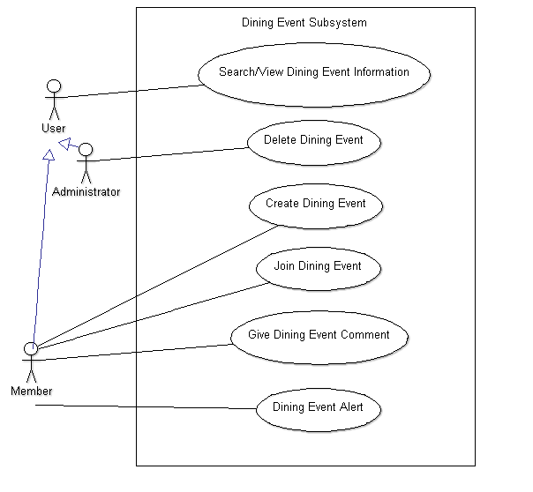

|  |  |  |
| --- | --- | --- |
| Use Case [number 18] | Search/View Dining Event Information | |
| Goal in Context | Search and view event | |
| Preconditions | Login as member or administrator | |
| Success End Condition | Events are shown | |
| Failed End Condition |  | |
| Primary Actor | Member or Administrator | |
| Secondary Actor |  | |
| Trigger | Select dining event on the home page | |
| Description | Step | Action |
|  | 1 | Select dining event on the home page |
|  | 2 | Input the information of the event to the search engine |
|  | 3 | Click search |
|  | 4 | Output the event information |
| Extensions or Variations | Step | If result not found |
|  | 1 | Output error message |
| Required Data | query, eventID, memberID. eventTitle, eventAim, eventDesc, eventStartTime, eventEndTime, eventDuration, eventMinParti, eventMaxParti, eventEstFee, eventMemberPointReward, eventStatus, eventIsPrivate, eventRestaurantName, eventAddress, DiningEventComment, DinigEventParticipantList | |
| Updated Data |  | |

|  |  |  |
| --- | --- | --- |
| Use Case [number 19] | Delete Dining Event | |
| Goal in Context | Delete a dining event | |
| Preconditions | Login administrator | |
| Success End Condition | An event is deleted | |
| Failed End Condition |  | |
| Primary Actor | Administrator | |
| Secondary Actor |  | |
| Trigger | Select dining event on the home page, search a dining event, and output the dining event | |
| Description | Step | Action |
|  | 1 | Click delete |
|  | 2 | Enter administrator password and press send and confirm delete button |
|  | 3 | Send the delete reason and number of member point will be deleted to the event organizer |
|  | 4 | Delete member point |
| Extensions or Variations | Step | Cancel delete |
| Required Data | query, eventID, memberID. eventTitle, eventAim, eventDesc, eventStartTime, eventEndTime, eventDuration, eventMinParti, eventMaxParti, eventEstFee, eventMemberPointReward, eventStatus, eventIsPrivate, eventRestaurantName, eventAddress, DiningEventComment, DinigEventParticipantList, memberPoint, messageBoxID, messageID, message RecipientID, messageSentTime, messageTitle, messageContent, messageStatus | |
| Updated Data | eventID, memberID. eventTitle, eventAim, eventDesc, eventStartTime, eventEndTime, eventDuration, eventMinParti, eventMaxParti, eventEstFee, eventMemberPointReward, eventStatus, eventIsPrivate, eventRestaurantName, eventAddress, DiningEventComment, DinigEventParticipantList, memberPoint, messageBoxID, messageID, message RecipientID, messageSentTime, messageTitle, messageContent, messageStatus | |

|  |  |  |
| --- | --- | --- |
| Use Case [number 19] | Create Dining Event | |
| Goal in Context | Create a dining event for other members join | |
| Preconditions | Login a member | |
| Success End Condition | An event is created | |
| Failed End Condition |  | |
| Primary Actor | Member | |
| Secondary Actor |  | |
| Trigger | Select dining event on the home page | |
| Description | Step | Action |
|  | 1 |  |
| Extensions or Variations | Step |  |
| Required Data | eventID, memberID. eventTitle, eventAim, eventDesc, eventStartTime, eventEndTime, eventDuration, eventMinParti, eventMaxParti, eventEstFee, eventMemberPointReward, eventStatus, eventIsPrivate, eventRestaurantName, eventAddress, DiningEventComment, DinigEventParticipantList, memberPoint | |
| Updated Data | eventID, memberID. eventTitle, eventAim, eventDesc, eventStartTime, eventEndTime, eventDuration, eventMinParti, eventMaxParti, eventEstFee, eventMemberPointReward, eventStatus, eventIsPrivate, eventRestaurantName, eventAddress, DiningEventComment, DinigEventParticipantList, memberPoint | |

|  |  |
| --- | --- |
| Use case name | Create Dining Event |
| Use case ID | DES-003 |
| Super use case | - |
| Actor(s) | Member |
| Brief description | Member create a dining event for another member to join |
| Precondition | 1) Login as member  2) Select dining event on the home page |
| Post-condition | 1) A dining event is created  2) Member point is added |
| Flows of events | 1) Select create dining event  2) Input all necessary information  3) Submit the information |
| Alternative flows and exceptions | 1) Give up to create a dining event  2) Back to dining event |
| Priority | High |
| Non-behavioral requirements | - |
| Assumptions | - |
| Issues | - |
| Source | - |

|  |  |
| --- | --- |
| Use case name | Join Dining Event |
| Use case ID | DES-004 |
| Super use case | - |
| Actor(s) | Member |
| Brief description | Member join a dining event held by another member |
| Precondition | 1) Login as member  2) Select dining event on the member’s home page  3) Search view/dining event information |
| Post-condition | 1) Join a dining event  2) Alert is sent to member who hold the dining event  3) Member point is added |
| Flows of events | Select join a dining event |
| Alternative flows and exceptions | Back to member’s home page |
| Priority | High |
| Non-behavioral requirements | - |
| Assumptions | - |
| Issues | - |
| Source | - |

|  |  |
| --- | --- |
| Use case name | Give Dining Event Comment |
| Use case ID | DES-005 |
| Super use case | - |
| Actor(s) | Member |
| Brief description | Member give comment of dining event to the member who hold the event |
| Precondition | 1) Login as member  2) Select dining event on the member’s home page  3) Select joint event |
| Post-condition | 1) Select the event that you want to comment  2) A comment is sent to the dining event page  3) Member point is added |
| Flows of events | 1) Select give comment  2) Write the comment  3) Select send |
| Alternative flows and exceptions | 1) Give up to give comment  2) Back to dining event |
| Priority | Low |
| Non-behavioral requirements | - |
| Assumptions | - |
| Issues | - |
| Source | - |

|  |  |
| --- | --- |
| Use case name | Dining Event Alert |
| Use case ID | DES-006 |
| Super use case | - |
| Actor(s) | System |
| Brief description | System send an email to remind you the details of the dining event automatically one hour before the event starts |
| Precondition | 1) Login as member  2) Select dining event on the member’s home page  3) Select dining event alert setting |
| Post-condition | Email is sent |
| Flows of events | Turn on the dining event alert |
| Alternative flows and exceptions | Turn off the dining event alert |
| Priority | Low |
| Non-behavioral requirements | - |
| Assumptions | You can receive the email |
| Issues | - |
| Source | - |

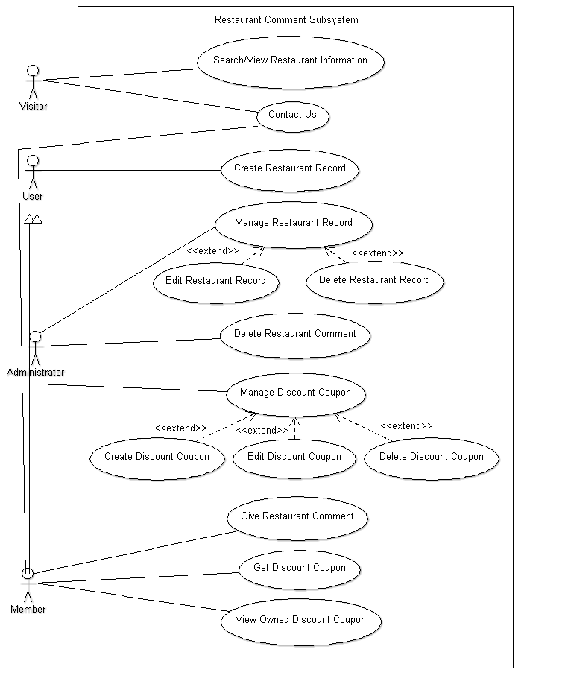

|  |  |  |
| --- | --- | --- |
| Use Case [number 001] | Member Register. | |
| Goal in Context | Visitor register as member | |
| Preconditions | Visitor is not member | |
| Success End Condition | Become a member | |
| Failed End Condition | Cannot become a member | |
| Primary Actor | Visitor | |
| Secondary Actor |  | |
| Trigger |  | |
| Description | Step | Action |
|  | 1 |  |
| Extensions or Variations | Step |  |
| Required Data |  | |
| Updated Data |  | |

|  |  |
| --- | --- |
| Use case name | Create Restaurant Record |
| Use case ID | RCS-002 |
| Super use case | - |
| Actor(s) | User (Administrator and Member) |
| Brief description | Input restaurant information for record |
| Precondition | 1) Login as administrator or member  2) Select restaurant at the home page |
| Post-condition | 1) A restaurant information is created  2) Member point is added |
| Flows of events | 1) Select create restaurant record  2) Input all necessary information  3) Submit the information |
| Alternative flows and exceptions | 1) Give up to create a restaurant record  2) Back to restaurant |
| Priority | High |
| Non-behavioral requirements | - |
| Assumptions | - |
| Issues | - |
| Source | - |

|  |  |
| --- | --- |
| Use case name | Edit Restaurant Record |
| Use case ID | RCS-003 |
| Super use case | - |
| Actor(s) | Administrator |
| Brief description | Administrator can edit restaurant information |
| Precondition | 1) Login as administrator  2) Select restaurant at the home page  3) Select search restaurant information |
| Post-condition | A restaurant’s information is change |
| Flows of events | 1) Select edit restaurant record  2) Input all necessary information  3) Submit the information |
| Alternative flows and exceptions | 1) Give up to create a restaurant record  2) Back to restaurant |
| Priority | High |
| Non-behavioral requirements | - |
| Assumptions | - |
| Issues | - |
| Source | - |

|  |  |
| --- | --- |
| Use case name | Delete Restaurant Record |
| Use case ID | RCS-004 |
| Super use case | - |
| Actor(s) | Administrator |
| Brief description | Administrator can delete restaurant record |
| Precondition | 1) Login as administrator  2) Select restaurant at the home page  3) Select search restaurant information |
| Post-condition | A restaurant’s information is deleted |
| Flows of events | 1) Select restaurant that you to delete  2) Press delete button  3) Enter administrator password and press confirm delete button |
| Alternative flows and exceptions | 1) Give up to delete a restaurant record  2) Back to restaurant |
| Priority | High |
| Non-behavioral requirements | - |
| Assumptions | - |
| Issues | - |
| Source | - |

|  |  |
| --- | --- |
| Use case name | Give Restaurant Comment |
| Use case ID | RCS-005 |
| Super use case | - |
| Actor(s) | Member |
| Brief description | Member give comment to a restaurant |
| Precondition | 1) Login as member  2) Select restaurant at the home page  3) Search the restaurant that you want to make comment  4) View the restaurant information |
| Post-condition | 1) A restaurant comment is created  2) Member point is added |
| Flows of events | 1) Select give restaurant comment  2) Write comment  3) Submit the comment |
| Alternative flows and exceptions | 1) Give up to give restaurant comment  2) Back to restaurant |
| Priority | High |
| Non-behavioral requirements | - |
| Assumptions | - |
| Issues | - |
| Source | - |

|  |  |
| --- | --- |
| Use case name | Delete Restaurant Comment |
| Use case ID | RCS-006 |
| Super use case | - |
| Actor(s) | Administrator |
| Brief description | Administrator can delete restaurant comment |
| Precondition | 1) Login as administrator  2) Select restaurant at the home page  3) Search the restaurant that you want to make comment  4) View the restaurant information |
| Post-condition | A restaurant comment is deleted |
| Flows of events | 1) Press delete button next to the comment  2) Enter administrator password and press confirm delete button |
| Alternative flows and exceptions | 1) Give up to delete a restaurant record  2) Back to restaurant |
| Priority | High |
| Non-behavioral requirements | - |
| Assumptions | - |
| Issues | - |
| Source | - |

|  |  |
| --- | --- |
| Use case name | Create Discount Coupon |
| Use case ID | RCS-007 |
| Super use case | - |
| Actor(s) | Administrator |
| Brief description | Administrator can create a discount coupon after restaurant owner approved |
| Precondition | 1) Login as administrator  2) Select discount coupon |
| Post-condition | A discount coupon is created |
| Flows of events | 1) Select create discount coupon  2) Type in necessary information  3) Select submit |
| Alternative flows and exceptions | 1) Give up to create a discount coupon  2) Back to discount coupon |
| Priority | Medium |
| Non-behavioral requirements | - |
| Assumptions | - |
| Issues | - |
| Source | - |

|  |  |
| --- | --- |
| Use case name | Edit Discount Coupon |
| Use case ID | RCS-008 |
| Super use case | - |
| Actor(s) | Administrator |
| Brief description | Administrator can edit a discount coupon |
| Precondition | 1) Login as administrator  2) Select discount coupon |
| Post-condition | The information of the coupon is changed |
| Flows of events | 1) Select the discount coupon you would like to edit  2) Change the information  3) Select submit |
| Alternative flows and exceptions | 1) Give up to edit a discount coupon  2) Back to discount coupon |
| Priority | Medium |
| Non-behavioral requirements | - |
| Assumptions | - |
| Issues | - |
| Source | - |

|  |  |
| --- | --- |
| Use case name | Delete Discount Coupon |
| Use case ID | RCS-009 |
| Super use case | - |
| Actor(s) | Administrator |
| Brief description | Administrator can delete discount coupon |
| Precondition | 1) Login as administrator  2) Select discount coupon |
| Post-condition | A discount coupon is deleted |
| Flows of events | 1) Select the discount coupon you would like to delete  2) Click delete button  3) Enter administrator password and press confirm delete button |
| Alternative flows and exceptions | 1) Give up to delete a discount coupon  2) Back to discount coupon |
| Priority | Medium |
| Non-behavioral requirements | - |
| Assumptions | - |
| Issues | - |
| Source | - |

|  |  |
| --- | --- |
| Use case name | Get Discount Coupon |
| Use case ID | RCS-010 |
| Super use case | - |
| Actor(s) | Member |
| Brief description | Member use his/her member point to buy discount coupon |
| Precondition | 1) Login as member  2) Select discount coupon |
| Post-condition | Get a discount coupon |
| Flows of events | 1) Select the discount coupon you would like get  2) Click get  3) Click confirm payment button |
| Alternative flows and exceptions | 1) Give up to get discount coupon  2) Back to discount coupon |
| Priority | Medium |
| Non-behavioral requirements | - |
| Assumptions | Member have enough member point |
| Issues | - |
| Source | - |

|  |  |
| --- | --- |
| Use case name | View Owned Discount Coupon |
| Use case ID | RCS-011 |
| Super use case | - |
| Actor(s) | Member |
| Brief description | Member can view bought discount coupon |
| Precondition | 1) Login as member  2) Select discount coupon |
| Post-condition | See what discount coupon can be used now |
| Flows of events | Select view owned discount coupon |
| Alternative flows and exceptions | Back to discount coupon |
| Priority | Medium |
| Non-behavioral requirements | - |
| Assumptions | - |
| Issues | - |
| Source | - |

|  |  |
| --- | --- |
| Use case name | Contact Us |
| Use case ID | RCS-012 |
| Super use case | - |
| Actor(s) | Visitor, Member |
| Brief description | Contact the site about business opportunity, e.g. advertisement or coupon, etc. |
| Precondition | - |
| Post-condition | The message is sent to administrator |
| Flows of events | 1) Click Contact on Business  2) Fill in information  3) Send the message |
| Alternative flows and exceptions | Back to home page |
| Priority | Low |
| Non-behavioral requirements | - |
| Assumptions | - |
| Issues | - |
| Source | - |

|  |  |  |
| --- | --- | --- |
| Use Case [number ] |  | |
| Goal in Context |  | |
| Preconditions |  | |
| Success End Condition |  | |
| Failed End Condition |  | |
| Primary Actor |  | |
| Secondary Actor |  | |
| Trigger |  | |
| Description | Step | Action |
|  | 1 |  |
| Extensions or Variations | Step |  |
| Required Data |  | |
| Updated Data |  | |